SIMATS ENGINEERING
ASSESSMENT TOOL 2: Industry Problem-Based Assignment
COURSE NAME: | ARTIFICIAL INTELLIGENCE AND EXPERT SYSTEMS | COURSE CODE: | MLA01

COURSE OUTCOME COVERED
CO 5: Construct rule-based expert systems using production rules, forward and backward chaining, and by distinguishing procedural and non-procedural paradigms across development stages.(BTL 3)
Assessment Tool Weightage: 40%
Total Marks: 100 Time: 90 Mins
No. of Questions: 1
Annexure A
Industry Problem-Based Assignment

Code of Conduct:
I SAHIL J.S (192525200) (Name / Reg No) certify that this submission is my original work and that I have adhered to the guidelines specified for this assessment.
I understand that any violation of academic integrity rules will result in disciplinary action.
Signature of the student: Sahil J.S
Criterion | Weightage | Marks Obtained
1. Problem Analysis and Domain Understanding | 10%
2. Knowledge Acquisition and Knowledge Representation | 10%
3. Production Rule / Knowledge Base Design | 15%
4. Prolog Implementation and Programming | 15%
5. Forward Chaining Implementation and Demonstration | 10%
6. Backward Chaining Implementation and Demonstration | 10%
7. Procedural and Non-Procedural Paradigm Analysis | 10%
8. Unification, Backtracking and Inference Accuracy | 10%
9. Testing, Results and System Demonstration | 5%
10. Documentation, GitHub Repository and Technical Presentation | 5%
Total | 100%

Signature of the Faculty Total Marks Awarded

1. Abstract
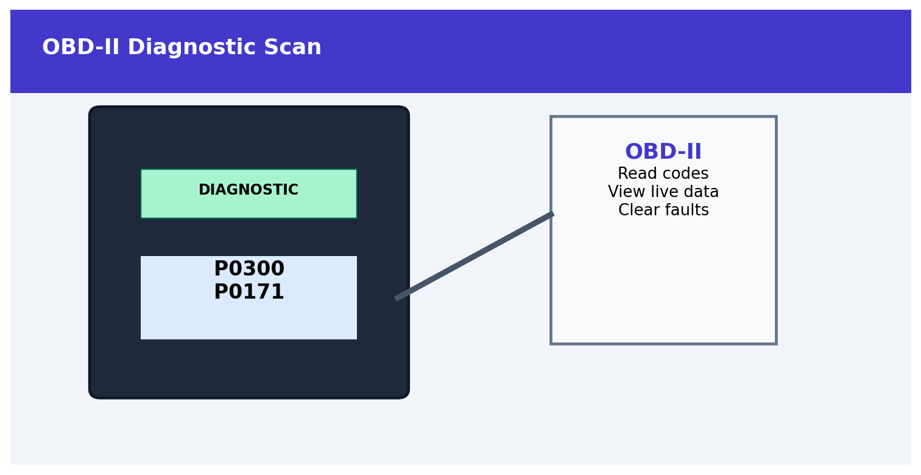
OBD-II Diagnostic Scan
Figure. Service-center vehicle inspection.
This project develops a Prolog-based expert system for an automobile service center. The system analyzes customer complaints such as engine overheating, difficulty starting, abnormal engine noise, low mileage and warning-light activation. These observations are represented as facts and production rules. Forward chaining derives probable faults from available observations, while backward chaining starts from a suspected fault and verifies the required symptoms. The system also recommends suitable diagnostic actions and explains the reasoning behind each conclusion.

2. Introduction and Industry Background
Automobile service centers receive large numbers of fault complaints. A technician must interpret symptoms, connect them with likely causes and decide which diagnostic action should be performed first. A rule-based expert system can capture repeatable diagnostic knowledge in a structured knowledge base and provide consistent preliminary decision support.
Industry Need | Expert-System Contribution
Rapid preliminary diagnosis | Matches symptoms with production rules.
Consistent troubleshooting | Uses the same logical rules for similar cases.
Explainable decisions | Shows the facts and rule responsible for a conclusion.
Knowledge preservation | Stores service knowledge as reusable rules.
Decision support | Suggests an appropriate next diagnostic action.

3. Problem Statement and Objectives
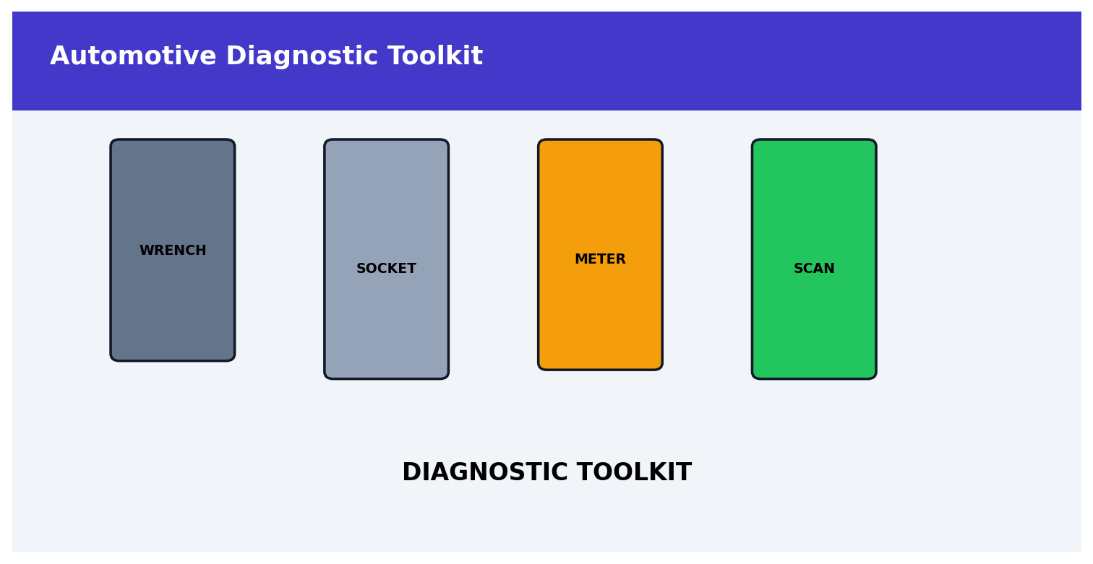
Automotive Diagnostic Toolkit
Figure. Engine component inspection.
A vehicle service center receives complaints such as engine overheating, difficulty starting, abnormal noise, low mileage and warning-light activation. The objective is to develop a Prolog-based expert system that identifies probable vehicle faults and recommends appropriate diagnostic actions using production rules and logical inference.

3.1 Objectives
- Identify probable automobile faults from observed symptoms.
- Represent diagnostic knowledge using Prolog facts, predicates and production rules.
- Implement and demonstrate forward chaining.
- Implement and demonstrate backward chaining.
- Demonstrate unification, backtracking and logical inference.
- Provide diagnostic actions linked to the inferred fault.
- Test the system using realistic automobile service scenarios.
- Compare procedural and declarative/non-procedural approaches.

4. Stakeholders, Inputs and Outputs
Item | Details
Stakeholders | Customer, service advisor, automobile technician, service-center manager.
Inputs | Overheating, starting difficulty, abnormal noise, low mileage, warning light, battery weakness, vibration and related observations.
Knowledge | Automotive troubleshooting relationships encoded as rules.
Processing | Rule matching using forward and backward reasoning.
Outputs | Probable fault, recommended diagnostic action and reasoning explanation.
Constraint | The system is preliminary decision support; final repair decisions require qualified inspection.

5. Domain Analysis and Knowledge Acquisition
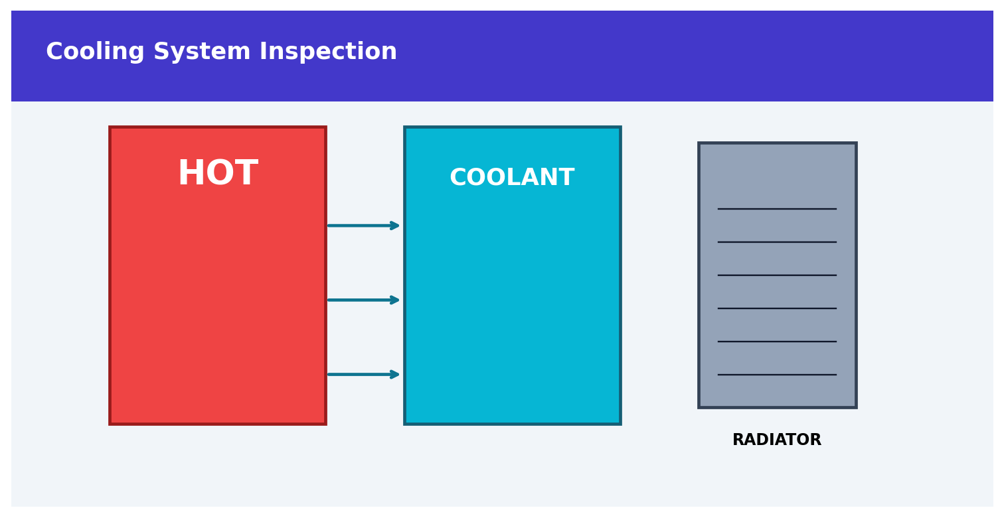
Cooling System Inspection
Figure. Vehicle sensor readings used for diagnosis.
The domain is modeled around observable vehicle symptoms, probable fault categories and recommended diagnostic actions. Knowledge is expressed in a form that can be translated directly into Prolog rules.
Entity / Fact | Example Meaning
engine_overheating | Engine temperature is abnormally high.
hard_start | Vehicle is difficult to start.
abnormal_noise | Unusual engine/mechanical noise is heard.
low_mileage | Fuel economy is lower than expected.
warning_light | Dashboard warning indicator is active.
weak_battery | Battery voltage/starting power appears weak.
coolant_low | Coolant level is below the required level.
engine_vibration | Abnormal engine vibration is observed.

5.1 Knowledge Acquisition Process
SERVICE COMPLAINTS
↓
IDENTIFY SYMPTOMS
↓
GROUP RELATED CONDITIONS
↓
DEFINE PROBABLE FAULTS
↓
MAP FAULTS TO DIAGNOSTIC ACTIONS
↓
CONVERT KNOWLEDGE INTO PROLOG RULES
↓
VALIDATE USING TEST CASES

6. Knowledge Representation and Production Rules
The knowledge base separates facts from rules. Facts describe observations. Production rules express diagnostic relationships in IF–THEN form.
Rule ID | Conditions | Probable Fault | Diagnostic Action
R1 | engine_overheating + coolant_low | cooling_system_issue | Check coolant level and inspect for leaks.
R2 | hard_start + weak_battery | battery_starting_issue | Test battery voltage and starting circuit.
R3 | abnormal_noise + engine_vibration | engine_mechanical_issue | Inspect engine mounts and mechanical components.
R4 | low_mileage + warning_light | fuel_or_engine_control_issue | Scan diagnostic codes and inspect engine-control/fuel systems.
R5 | engine_overheating + warning_light | cooling_system_issue | Check coolant system and scan warning codes.
R6 | hard_start + warning_light | starting_or_engine_control_issue | Scan fault codes and inspect starting/engine-control systems.
R7 | low_mileage + abnormal_noise | engine_performance_issue | Inspect engine condition and perform performance checks.
R8 | engine_vibration + warning_light | engine_control_or_mechanical_issue | Scan codes and inspect for mechanical abnormalities.

7. Expert System Architecture
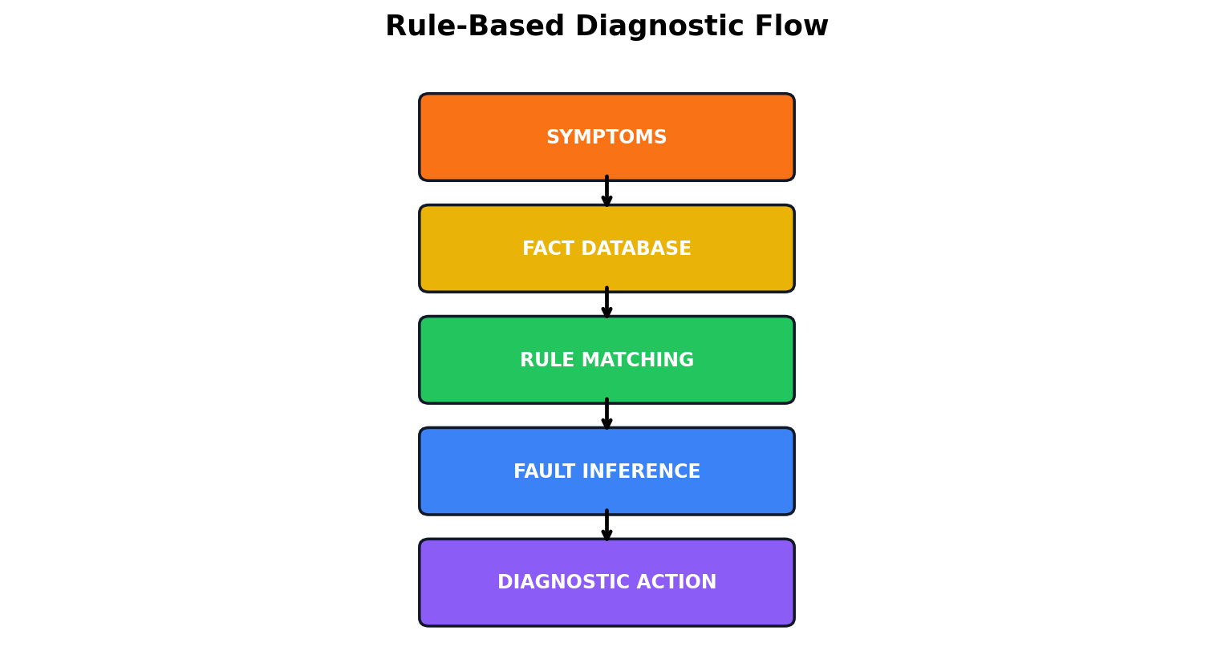
Figure. Reworked diagnostic inference flowchart.

OBD-II Diagnostic Scan
Figure. OBD-II diagnostic scanning.
Figure 1. Architecture of the Automobile Fault Diagnosis Expert System.

8. Inference Mechanism
The inference engine uses two reasoning strategies. Forward chaining begins with known vehicle observations and derives conclusions. Backward chaining begins with a target fault and verifies whether the observations needed for that fault are available.
Figure 2. Forward and backward chaining comparison.
Figure 2. Forward and backward chaining overview.

9. Forward Chaining Demonstration

Cooling System Inspection
Figure. Rule-based automotive diagnostic workflow.
Scenario: A vehicle has engine overheating and low coolant. The system starts from these known facts and fires the applicable rule.
Step | Current Facts / Action | Inference
1 | engine_overheating, coolant_low | Initial facts
2 | Evaluate R1 | All R1 conditions satisfied
3 | Fire R1 | cooling_system_issue derived
4 | Map fault to action | Check coolant level and inspect for leaks
5 | Evaluate remaining rules | No additional rule required for this scenario
6 | Final result | Probable fault: cooling_system_issue

9.1 Forward Chaining Pseudocode
FORWARD_CHAIN(Facts, Rules)
Derived <- Facts
REPEAT
NewFact <- FALSE
FOR each Rule in Rules
IF every condition of Rule is in Derived THEN
IF conclusion is not in Derived THEN
add conclusion to Derived
NewFact <- TRUE
END FOR
UNTIL NewFact = FALSE
RETURN Derived

10. Backward Chaining Demonstration
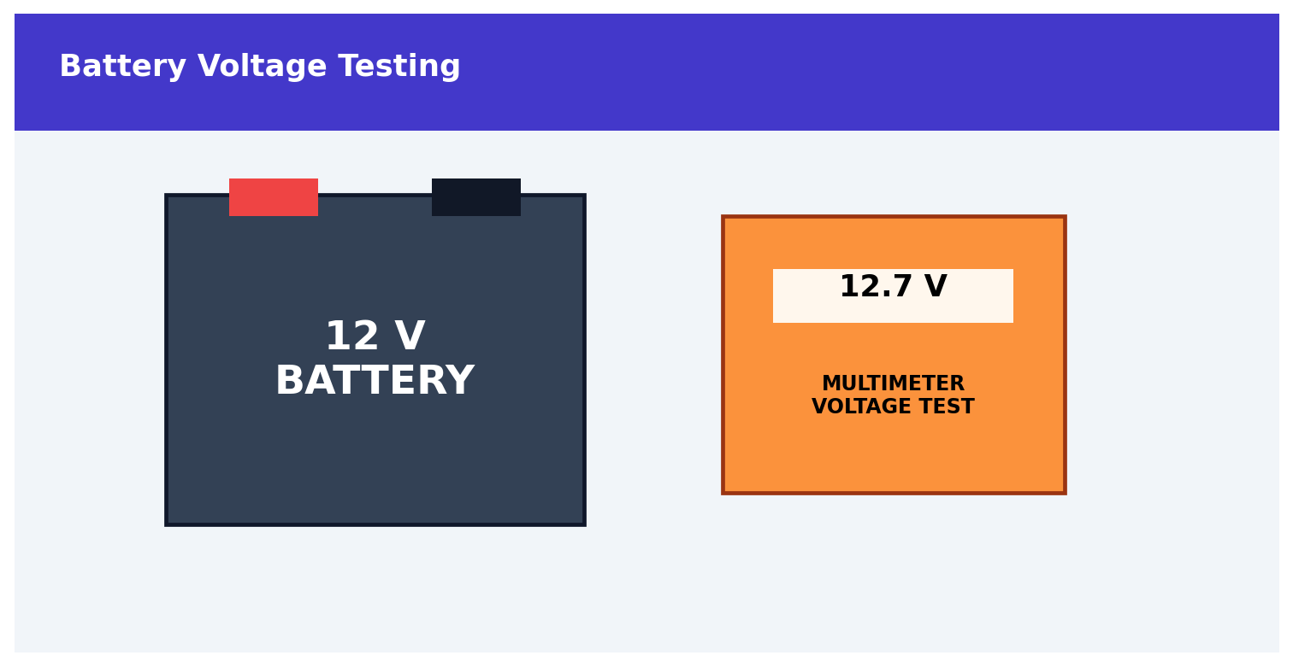
Battery Voltage Testing
Figure. OBD-II diagnostic scanning.
Battery and starting-system check
Goal: determine whether cooling_system_issue can be established. The system searches for a rule whose conclusion is cooling_system_issue and then verifies the required symptoms.
Step | Goal / Sub-goal | Result
1 | Goal = cooling_system_issue | Start
2 | Find R1 or R5 | Matching rule found
3 | Check engine_overheating | Fact exists → TRUE
4 | Check coolant_low (for R1) | Fact exists → TRUE
5 | All R1 conditions satisfied | Goal proven
6 | Final | cooling_system_issue

10.1 Backward Chaining Pseudocode
BACKWARD_CHAIN(Goal, Facts, Rules)
IF Goal is in Facts
RETURN TRUE
FOR each Rule whose conclusion matches Goal
IF every condition of Rule can be proved
RETURN TRUE
RETURN FALSE

11. Prolog Implementation

OBD-II Diagnostic Scan
Figure. Vehicle sensor readings used for diagnosis.
SWI-Prolog is used to implement the knowledge base and inference queries. The following program represents representative service-center observations, production rules and diagnostic actions.
% ---------- VEHICLE FACTS ----------
symptom(engine_overheating).
symptom(coolant_low).
% ---------- DIAGNOSIS RULES ----------
fault(cooling_system_issue) :-
symptom(engine_overheating),
symptom(coolant_low).
fault(battery_starting_issue) :-
symptom(hard_start),
symptom(weak_battery).
fault(engine_mechanical_issue) :-
symptom(abnormal_noise),
symptom(engine_vibration).
fault(fuel_or_engine_control_issue) :-
symptom(low_mileage),
symptom(warning_light).
fault(cooling_system_issue) :-
symptom(engine_overheating),
symptom(warning_light).
fault(starting_or_engine_control_issue) :-
symptom(hard_start),
symptom(warning_light).
fault(engine_performance_issue) :-
symptom(low_mileage),
symptom(abnormal_noise).
fault(engine_control_or_mechanical_issue) :-
symptom(engine_vibration),
symptom(warning_light).
% ---------- DIAGNOSTIC ACTIONS ----------
action(cooling_system_issue,
'Check coolant level and inspect for leaks.').
action(battery_starting_issue,
'Test battery voltage and starting circuit.').
action(engine_mechanical_issue,
'Inspect engine mounts and mechanical components.').
action(fuel_or_engine_control_issue,
'Scan diagnostic codes and inspect fuel/engine-control systems.').
action(starting_or_engine_control_issue,
'Scan fault codes and inspect starting/engine-control systems.').
action(engine_performance_issue,
'Inspect engine condition and perform performance checks.').
action(engine_control_or_mechanical_issue,
'Scan codes and inspect mechanical abnormalities.').
% ---------- COMBINED OUTPUT ----------
diagnosis(Fault, Action) :-
fault(Fault),
action(Fault, Action).

11.1 Example Queries and Expected Output
?- fault(cooling_system_issue).
true.
?- diagnosis(Fault, Action).
Fault = cooling_system_issue,
Action = 'Check coolant level and inspect for leaks.'.
The query fault(Fault) asks Prolog to find a matching fault. The query diagnosis(Fault, Action) also retrieves the diagnostic action associated with the inferred fault.

12. Unification and Backtracking

12.1 Unification
Unification allows Prolog to match a variable with a compatible term. In the query fault(Fault), the variable Fault can be unified with cooling_system_issue when the corresponding rule succeeds.
?- fault(Fault).
Fault = cooling_system_issue.

12.2 Backtracking
If multiple rules can succeed, Prolog can backtrack to the next applicable clause when the user requests another solution. This is useful when a vehicle exhibits symptoms that support more than one probable fault.
?- fault(Fault).
Fault = cooling_system_issue ;
Fault = battery_starting_issue ;
Fault = engine_mechanical_issue ;
false.

12.3 Inference Accuracy
- Every diagnosis is supported by an explicit production rule.
- Negative cases are included to ensure unsupported faults are not invented.
- Multiple matching rules are allowed when symptoms overlap.
- Diagnostic actions are linked to fault categories.
- Backtracking allows alternative conclusions to be explored.

13. Procedural vs Non-Procedural Paradigm
Aspect | Procedural Approach | Declarative / Prolog Approach
Focus | How the diagnosis should be executed | What facts and relationships are true
Control | Programmer controls sequence | Prolog inference controls search
Knowledge | Often mixed with algorithm | Separated into facts and rules
Reasoning | Explicit if/else and loops | Logical rule matching
Backtracking | Usually implemented manually | Built into Prolog
Maintenance | Algorithm changes may be required | Rules can be modified independently
Example | if symptomA and symptomB then... | fault(F) :- symptom(A), symptom(B).

Figure 3. Vehicle diagnostic decision flowchart.

14. Industry-Based Test Cases and Results
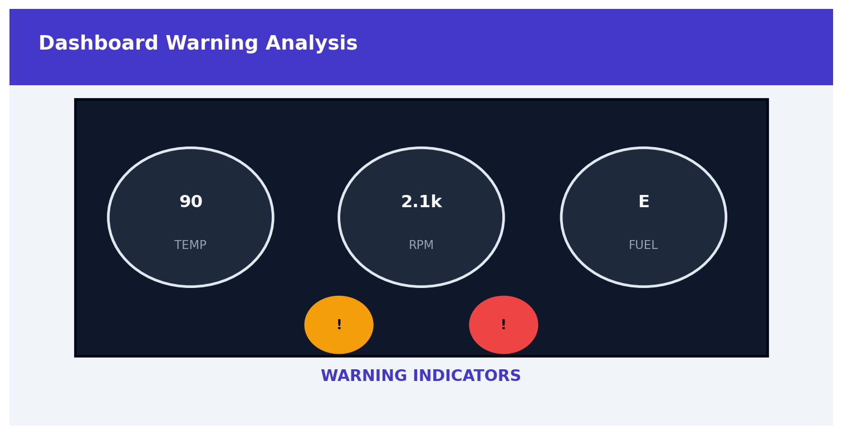
Dashboard Warning Analysis
Figure. Service-center vehicle inspection.
Test | Input Facts | Expected Fault | Expected Action | Status
TC01 | engine_overheating, coolant_low | cooling_system_issue | Check coolant level and inspect for leaks. | PASS
TC02 | hard_start, weak_battery | battery_starting_issue | Test battery voltage and starting circuit. | PASS
TC03 | abnormal_noise, engine_vibration | engine_mechanical_issue | Inspect engine mounts and mechanical components. | PASS
TC04 | low_mileage, warning_light | fuel_or_engine_control_issue | Scan codes and inspect fuel/engine-control systems. | PASS
TC05 | engine_overheating, warning_light | cooling_system_issue | Check coolant system and scan warning codes. | PASS
TC06 | hard_start, warning_light | starting_or_engine_control_issue | Scan codes and inspect starting/engine-control systems. | PASS
TC07 | low_mileage, abnormal_noise | engine_performance_issue | Inspect engine condition and perform performance checks. | PASS
TC08 | engine_vibration, warning_light | engine_control_or_mechanical_issue | Scan codes and inspect mechanical abnormalities. | PASS
TC09 | warning_light only | No matching fault from current rules | No action generated. | PASS

15. Detailed Inference Traces
Case | Reasoning Trace | Conclusion
TC01 | engine_overheating + coolant_low → R1 → cooling_system_issue | Cooling-system issue
TC02 | hard_start + weak_battery → R2 → battery_starting_issue | Battery/starting issue
TC03 | abnormal_noise + engine_vibration → R3 → engine_mechanical_issue | Engine mechanical issue
TC04 | low_mileage + warning_light → R4 → fuel_or_engine_control_issue | Fuel/engine-control issue
TC05 | engine_overheating + warning_light → R5 → cooling_system_issue | Cooling-system issue

16. Analysis and Interpretation of Results

Automotive Diagnostic Toolkit
Figure. Engine component inspection.
Factor | Observation | Interpretation
Rule coverage | Rules cover the five complaint types named in the industry problem and related combinations. | Good preliminary coverage.
Reasoning accuracy | Each positive result is traceable to a rule. | High explainability.
Consistency | Same facts produce the same rule-based result. | Consistent.
Negative testing | Insufficient facts do not trigger unsupported rules. | Prevents arbitrary conclusions.
Industry usefulness | Can support first-level troubleshooting and prioritization. | Useful as decision support.
Scalability | Additional fault rules can be added. | Knowledge base is extensible.

17. Limitations
- The system uses a simplified rule base and cannot represent the full complexity of modern vehicles.
- Sensor readings, diagnostic trouble codes, vehicle model, service history and technician inspection are not fully modeled.
- Some symptoms may have several possible causes, so multiple conclusions can be valid.
- The system provides preliminary decision support and does not replace qualified mechanical inspection.
- Rule quality depends on the accuracy and completeness of the knowledge base.

18. Future Enhancements

OBD-II Diagnostic Scan
Figure. OBD-II diagnostic scanning.
- Add vehicle make, model, year and engine type as input parameters.
- Integrate OBD-II diagnostic trouble codes.
- Add sensor values such as coolant temperature, battery voltage and engine RPM.
- Introduce confidence scores for competing probable faults.
- Build a graphical user interface for service advisors.
- Store previous service history for more personalized troubleshooting.
- Connect the system to a structured maintenance database.
- Add an explanation module that displays the complete inference path.
Figure 4. Logical inference workflow with unification and backtracking.

19. Documentation and GitHub Structure
automobile-expert-system/
|
|-- automobile_fault.pl
|-- README.md
|-- test_cases.txt
|-- screenshots/
| |-- forward_chaining.png
| |-- backward_chaining.png
| `-- prolog_output.png
`-- report/
`-- CO5_AT2_Report.docx
The README should include the project objective, SWI-Prolog requirement, execution instructions, sample queries, expected outputs and test evidence. The repository should be organized so that the evaluator can reproduce the demonstration.

20. Conclusion
The Automobile Fault Diagnosis Expert System applies rule-based artificial intelligence to a practical service-center problem. It represents vehicle observations as Prolog facts and connects them to probable faults and diagnostic actions using production rules. Forward chaining demonstrates data-driven reasoning, while backward chaining demonstrates goal-driven reasoning. Unification and backtracking illustrate important Prolog inference capabilities. The test cases show that the system can provide consistent, explainable preliminary troubleshooting support. With additional vehicle-specific knowledge, sensor data and diagnostic codes, the system can be extended into a more comprehensive automotive decision-support platform.

21. Viva Questions and Answers
Question | Answer
Why is Prolog suitable for this system? | Prolog represents facts and rules naturally and supports logical inference, unification and backtracking.
What is a production rule? | An IF–THEN relationship that derives a conclusion when its conditions are satisfied.
What is forward chaining? | A data-driven approach that starts from known vehicle facts and applies matching rules.
What is backward chaining? | A goal-driven approach that starts from a suspected fault and verifies its supporting conditions.
Why use both methods? | They provide two complementary views of the same diagnostic knowledge.
What is unification? | Matching compatible Prolog terms and binding variables to values.
What is backtracking? | Searching alternative matching clauses after a previous choice point.
Why are test cases necessary? | They verify rule correctness, coverage, consistency and expected outputs.
What is the main limitation? | The rule base is simplified and cannot replace professional vehicle inspection.

22. References
- SIMATS Engineering, Assessment Tool 2: Industry Problem-Based Assignment, Artificial Intelligence and Expert Systems (MLA01).
- SWI-Prolog Documentation and Reference.
- Bratko, I., Prolog Programming for Artificial Intelligence, Pearson.
- Russell, S. and Norvig, P., Artificial Intelligence: A Modern Approach, Pearson.
- Giarratano, J. and Riley, G., Expert Systems: Principles and Programming

24. Visual Summary of the Developed System
The following diagrams summarize the complete working of the proposed automobile expert system.

